BMED 712

Spring 2026

PBL Structure
1 – Clinical Understanding & Problem Framing
- Clinical background research
- Stakeholder needs mapping (patient, therapist, physician)
- Define engineering requirements
2 – Solution Design & Feasibility
- System architecture
- Sensors, algorithms, workflows
- Risk analysis & validation plan
3 – Translation & Communication
- Clinical impact justification
- Prototype sketches / block diagrams
- Final presentation + clinician-style summary
Below are clinically grounded PBL example problems suitable for a 3-week undergraduate Biomedical Engineering (BME) course focused on Neurology and Rehabilitation, aligned with real referral-style challenges typically seen at Cleveland Clinic Abu Dhabi (CCAD) and Specialized Rehabilitation (SRH).
Each problem is intentionally open-ended, multidisciplinary, and scoped for teams of 3 students

PBL Problem 1: Post-Stroke Gait Asymmetry & Fall Risk
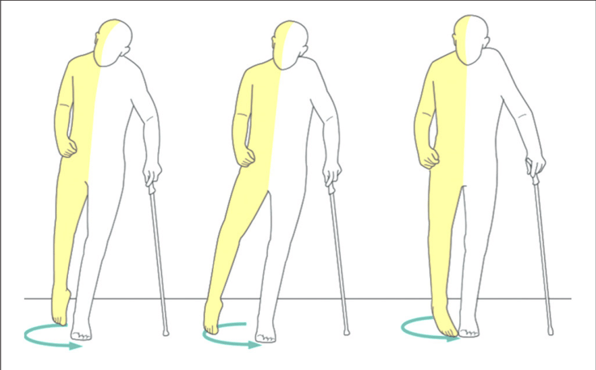
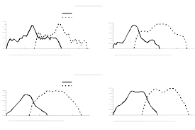
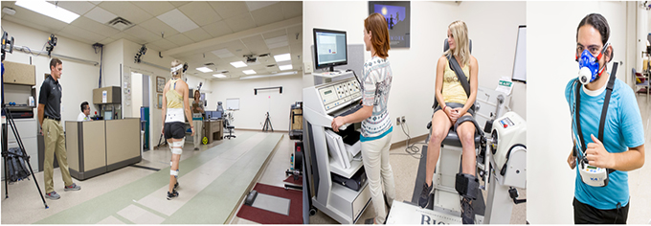
Clinical scenario (from SSRC):
A 62-year-old male, 6 months post-ischemic stroke, presents with persistent gait asymmetry and frequent near-falls during community ambulation. Force-plate access is limited, and clinicians rely mainly on observational gait assessment.
Engineering challenge:
Design a wearable or clinic-deployable system to quantify gait asymmetry and loading deficits and translate results into actionable rehab metrics.
Key constraints
- Low cost and deployable outside gait labs
- Interpretable outputs for physiotherapists
- Minimal setup time (<5 minutes)
Student deliverables
- Biomechanical rationale (e.g., GRF surrogates, stance asymmetry)
- Sensor selection (IMUs, pressure insoles, EMG, etc.)
- Signal processing + basic validation plan
- Dashboard mock-up for clinicians
- Ethical & usability considerations

PBL Problem 2: Monitoring Neuroplastic Recovery After Stroke
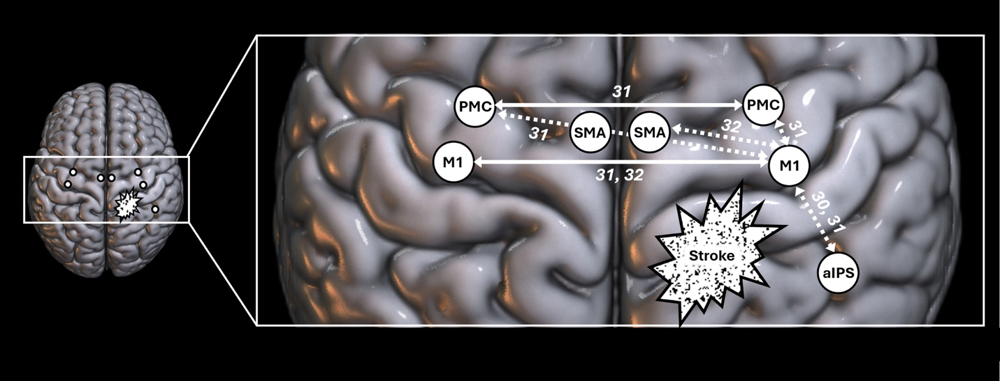
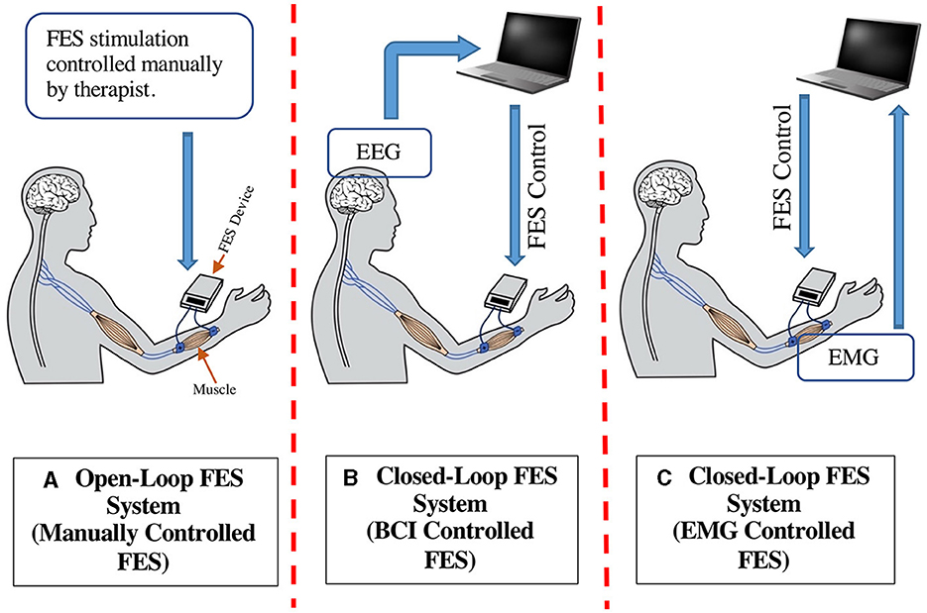
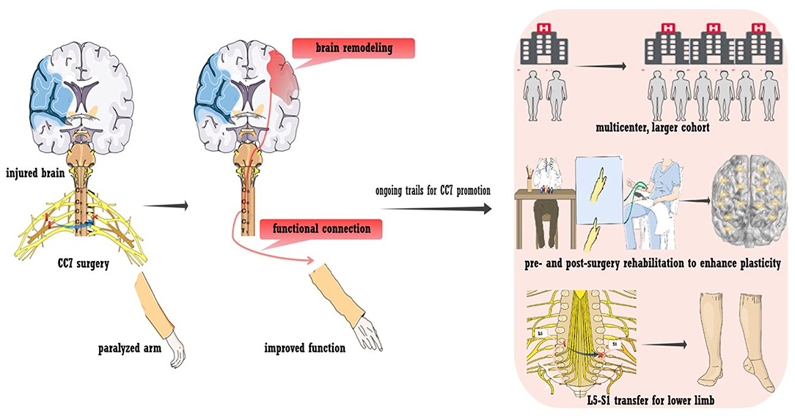
Clinical scenario (from CCAD Neuro-Rehab):
Therapists observe functional improvement in upper-limb tasks, but lack objective markers of neuroplastic recovery to guide therapy intensity.
Engineering challenge:
Propose a non-invasive neurophysiological monitoring framework to track recovery over a 12-week rehabilitation program.
Key constraints
- Non-invasive and patient-tolerant
- Repeatable across sessions
- Clinically interpretable (not just raw EEG metrics)
Student deliverables
- Choice of modality (EEG, fNIRS, or multimodal)
- Proposed biomarkers (e.g., coherence, laterality index)
- Experimental protocol embedded in therapy
- Clinical interpretation guide (what does “improvement” mean?)
- Limitations and validation strategy

PBL Problem 3: Detecting Freezing of Gait in Parkinson’s Disease
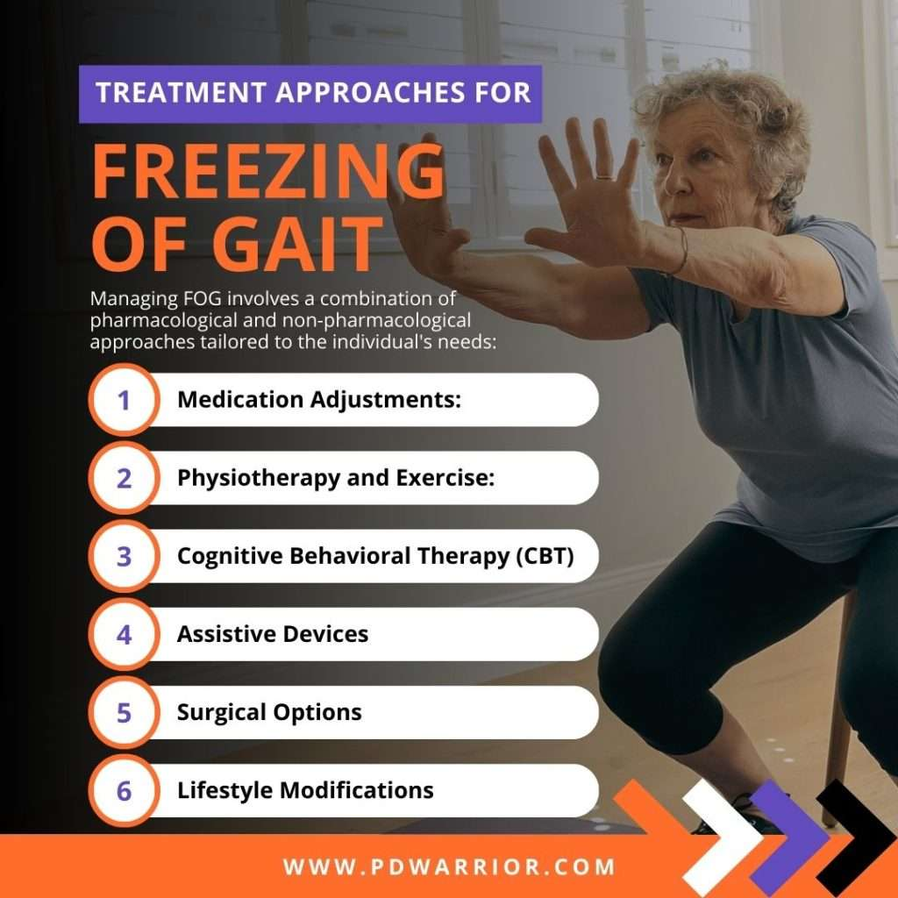
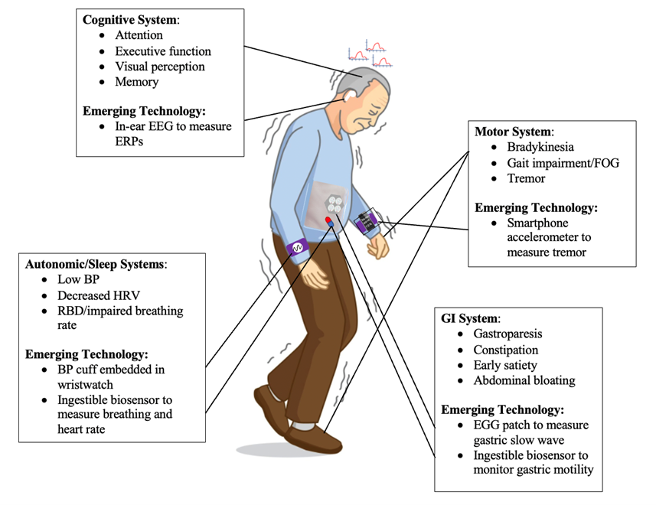
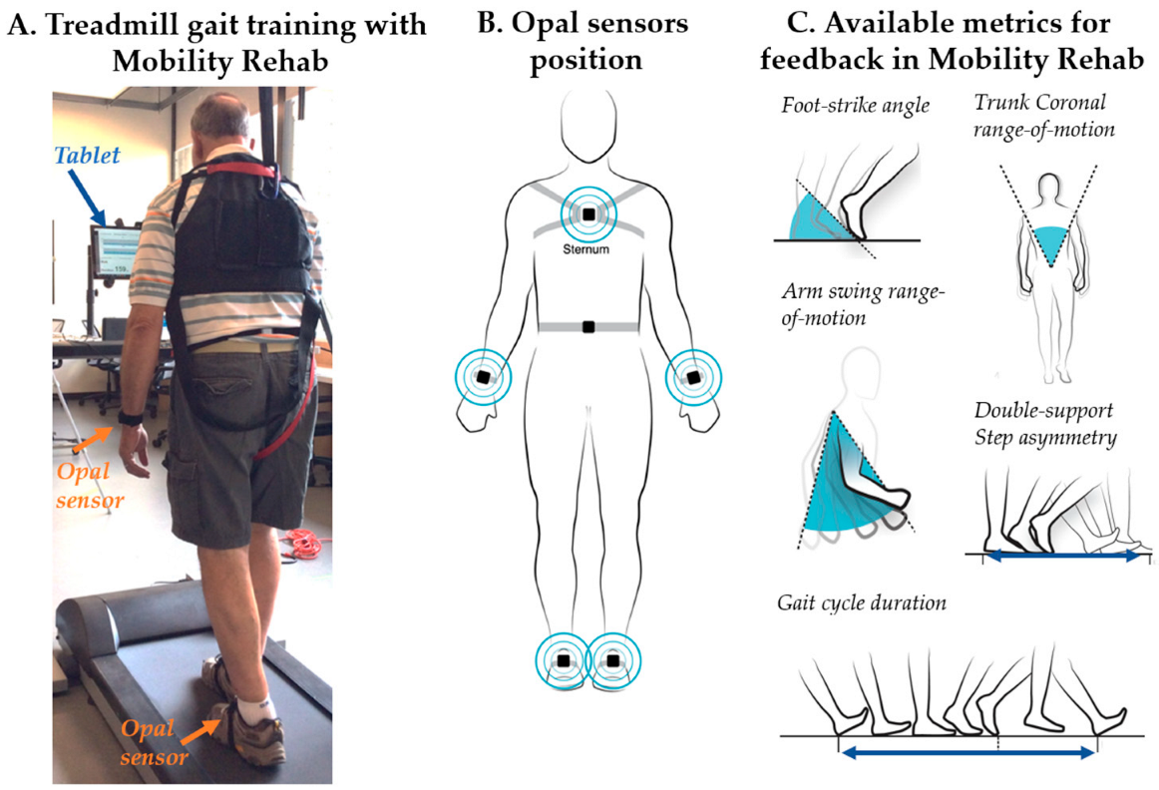
Clinical scenario (from CCAD Movement Disorders Clinic):
Patients with Parkinson’s disease report episodic freezing of gait (FoG) at home, but symptoms are rarely captured during clinic visits.
Engineering challenge:
Design a home-monitoring system that can detect FoG episodes and provide meaningful summaries to clinicians.
Key constraints
- Home-based, unsupervised use
- Low false positives
- Minimal patient burden
Student deliverables
- Sensor and placement strategy
- FoG detection logic (rule-based or ML-assisted)
- Data visualization for neurologists
- Discussion of privacy and long-term adherence
- Proposed clinical impact

PBL Problem 4: Personalized Upper-Limb Rehab After Traumatic Brain Injury
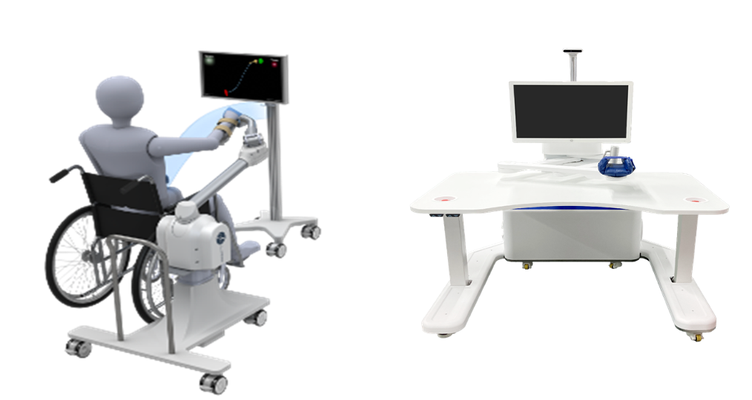

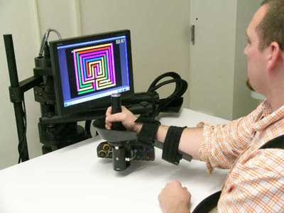
Clinical scenario (from SSRC):
Two TBI patients with similar clinical scores respond very differently to the same robotic therapy protocol.
Engineering challenge:
Develop a patient-adaptive rehabilitation system that personalizes therapy based on real-time physiological or biomechanical feedback.
Key constraints
- Adaptation must be explainable to clinicians
- No increase in therapy session duration
- Compatible with existing rehab workflows
Student deliverables
- Personalization parameters (EMG, kinematics, fatigue indices)
- Control/adaptation concept (logic diagram)
- Safety considerations
- Expected benefits vs standard therapy
- Evaluation metrics

PBL Problem 5: Cognitive-Motor Interference During Rehabilitation
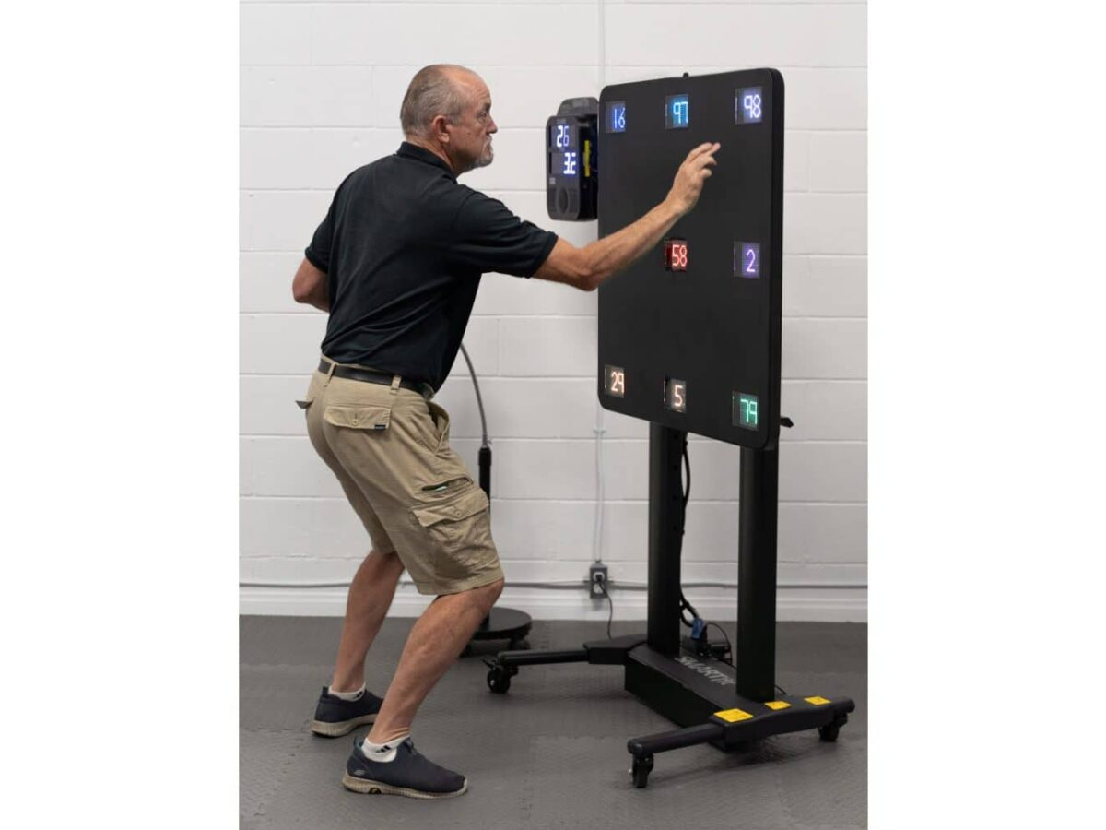
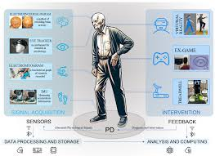
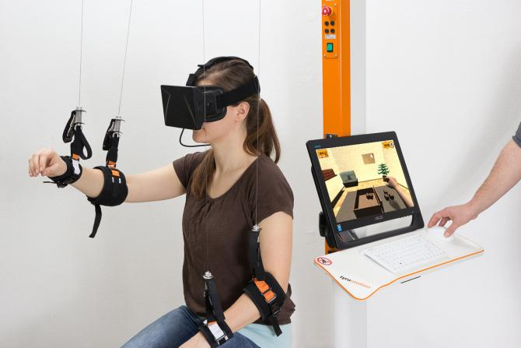
Clinical scenario (from CCAD Rehab):
Patients walk well in therapy rooms but deteriorate significantly in real-world environments requiring attention and decision-making.
Engineering challenge:
Design an assessment or training system that quantifies and rehabilitates cognitive-motor interference (CMI).
Key constraints
- Safe for neurological patients
- Clinically scalable
- Objective outcome metrics
Student deliverables
- Task design (dual-task or VR-based)
- Physiological/behavioral metrics (EEG, HRV, gait)
- Scoring framework for clinicians
- Ethical and accessibility considerations
- Pathway to clinical adoption

PBL Problem 6: Rapid Stroke Triage Beyond Imaging
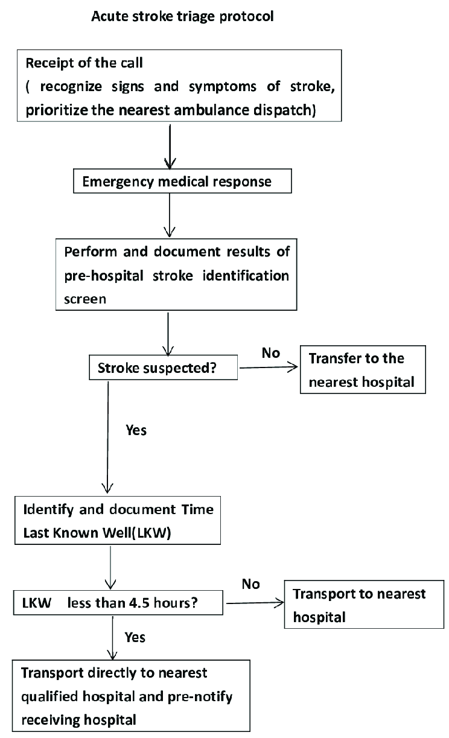
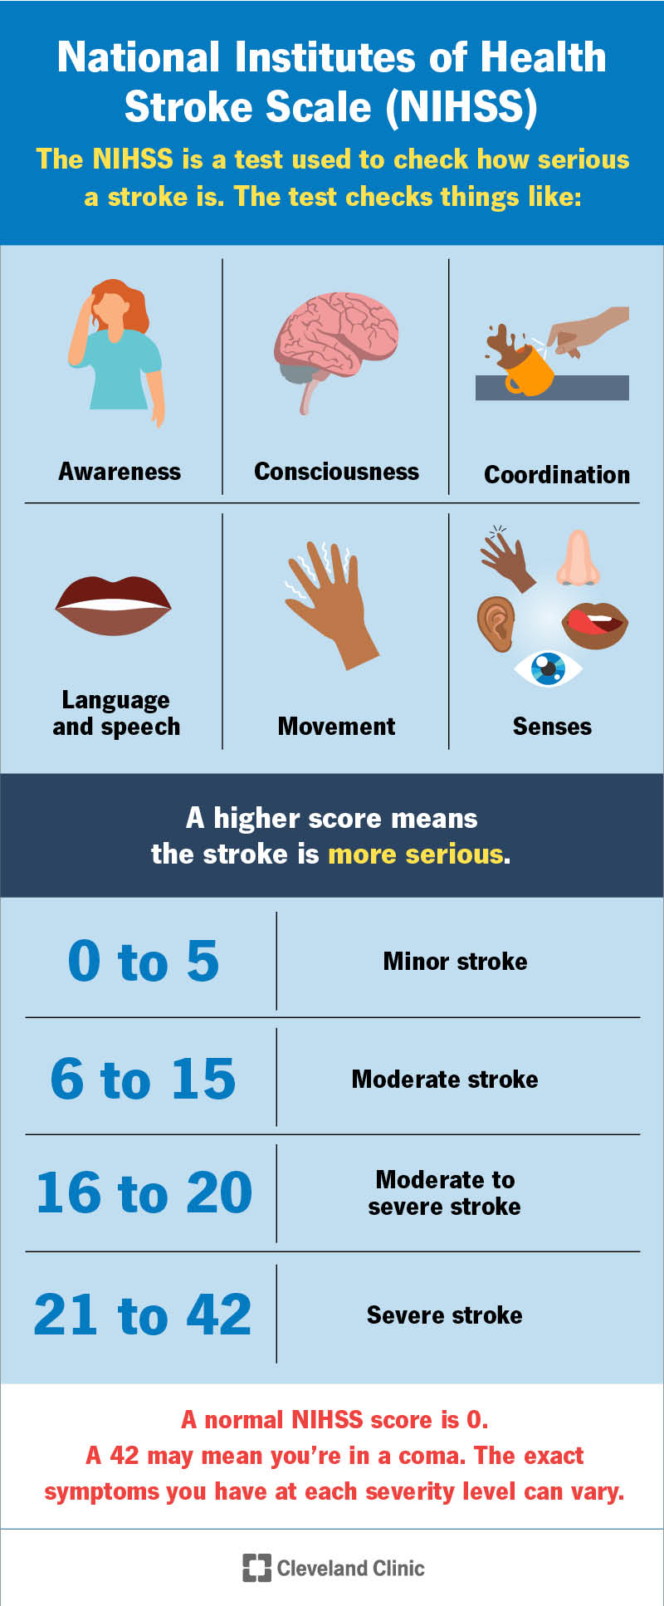
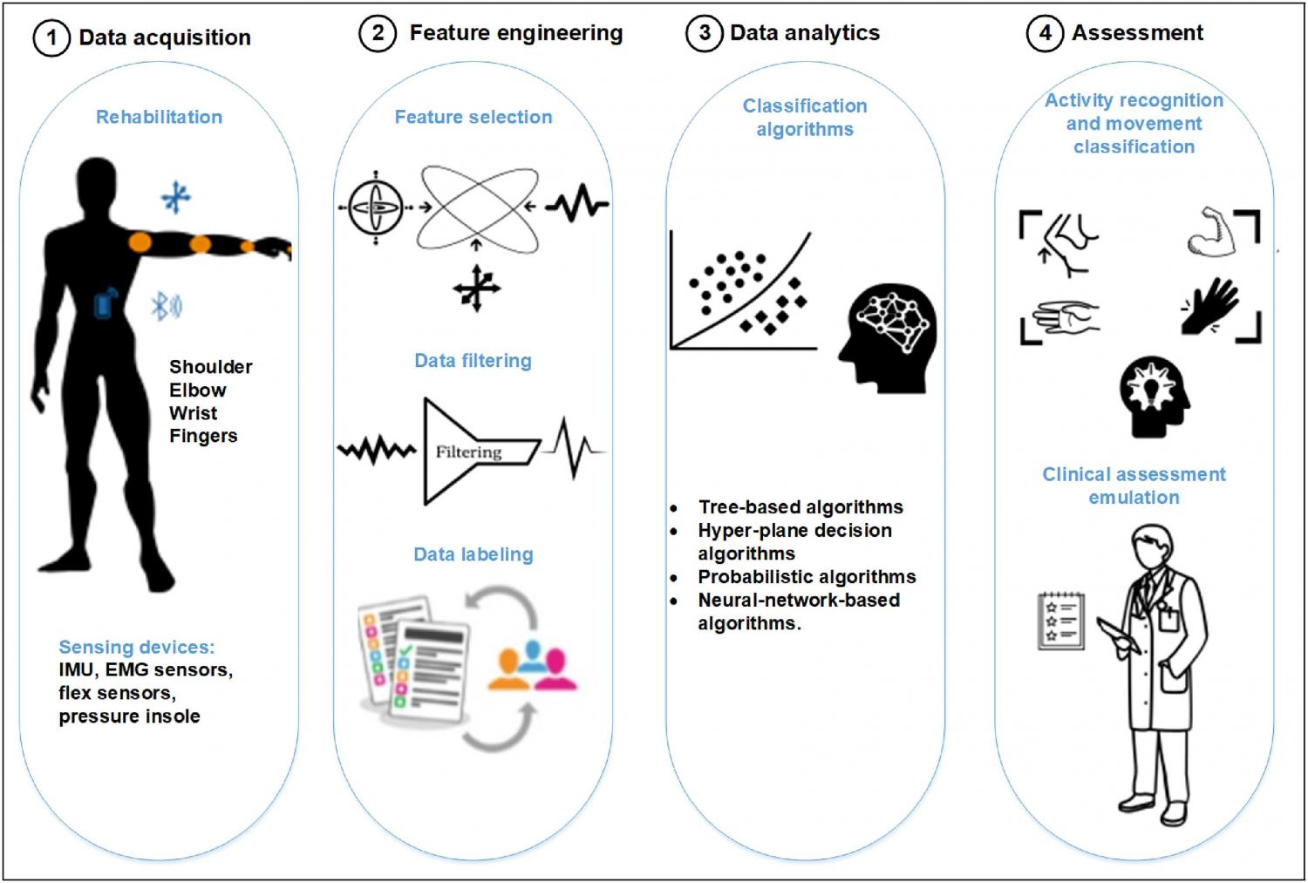
Clinical context (Emergency & Stroke Program):
In the hyperacute stroke pathway, imaging determines eligibility for thrombectomy or thrombolysis. However, imaging access and turnaround time can delay decision-making, especially during peak hours.
Engineering challenge:
Design a bedside or pre-imaging decision-support system that integrates physiological, neurological, or behavioral markers to support rapid stroke severity stratification.
Constraints
- Must complement—not replace—imaging
- Fast (<5 minutes), minimal setup
- Outputs interpretable by emergency clinicians
Expected focus
- Signal sources (EEG, vitals, speech, eye movement, motor asymmetry)
- Feature selection linked to stroke severity
- Clinical workflow integration and risk mitigation

PBL Problem 7: Objective Localization Support in Drug-Resistant Epilepsy
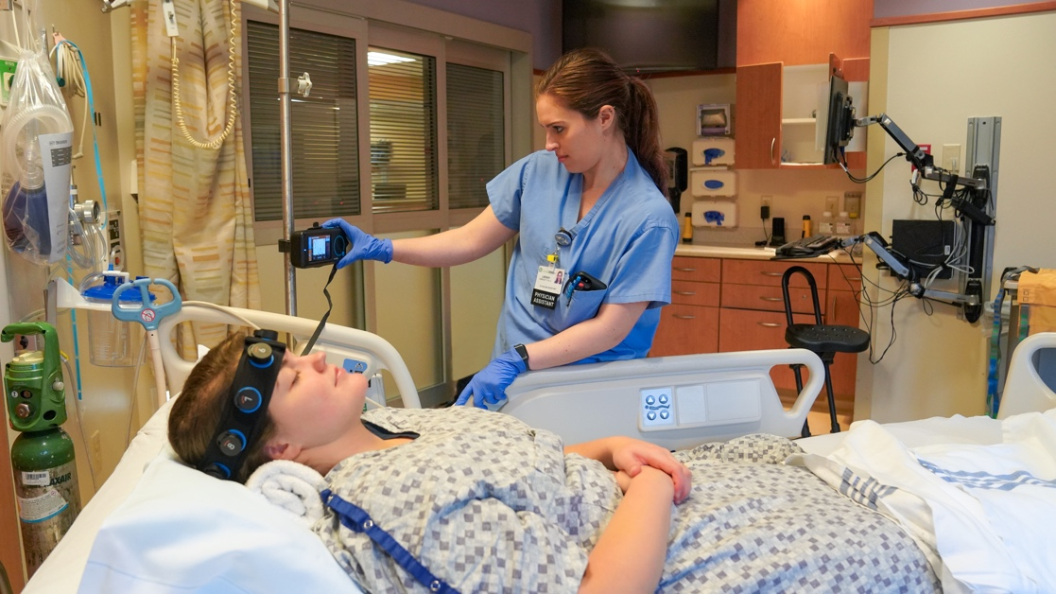

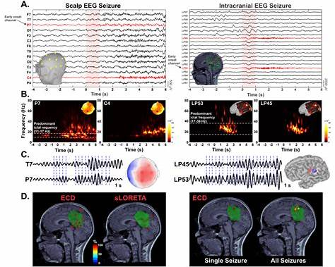
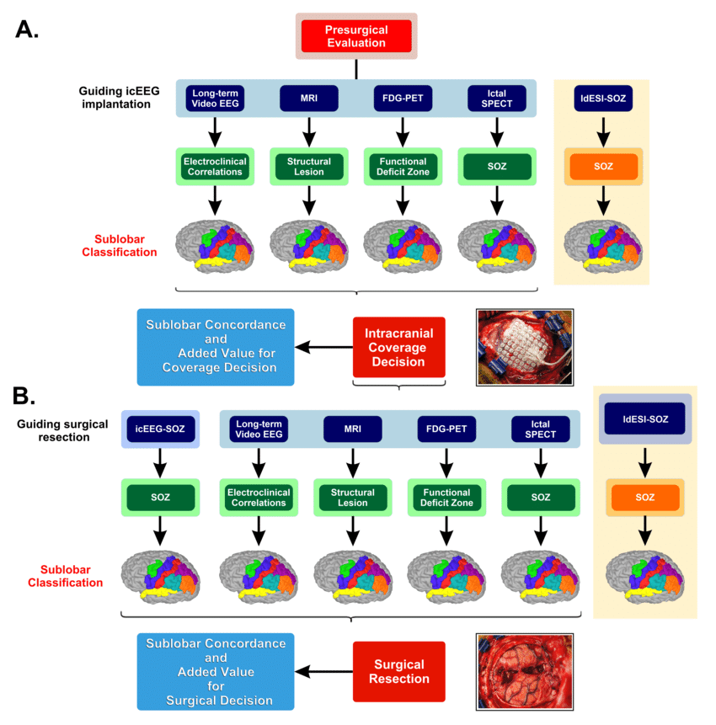
Clinical context (Epilepsy Program):
Patients with drug-resistant epilepsy undergo prolonged EEG monitoring, yet manual review and seizure localization remain time-intensive and subjective.
Engineering challenge:
Propose an engineering tool or pipeline that assists clinicians in identifying seizure onset zones or abnormal network patterns from EEG or multimodal data.
Constraints
- Assistive (not autonomous) system
- Explainable outputs for neurologists
- Must handle noisy, long-duration recordings
Expected focus
- Signal processing / AI logic (classical or ML-based)
- Visualization of spatiotemporal patterns
- Validation strategy against expert annotations

PBL Problem 8: Predicting Functional Decline in Parkinson’s Disease

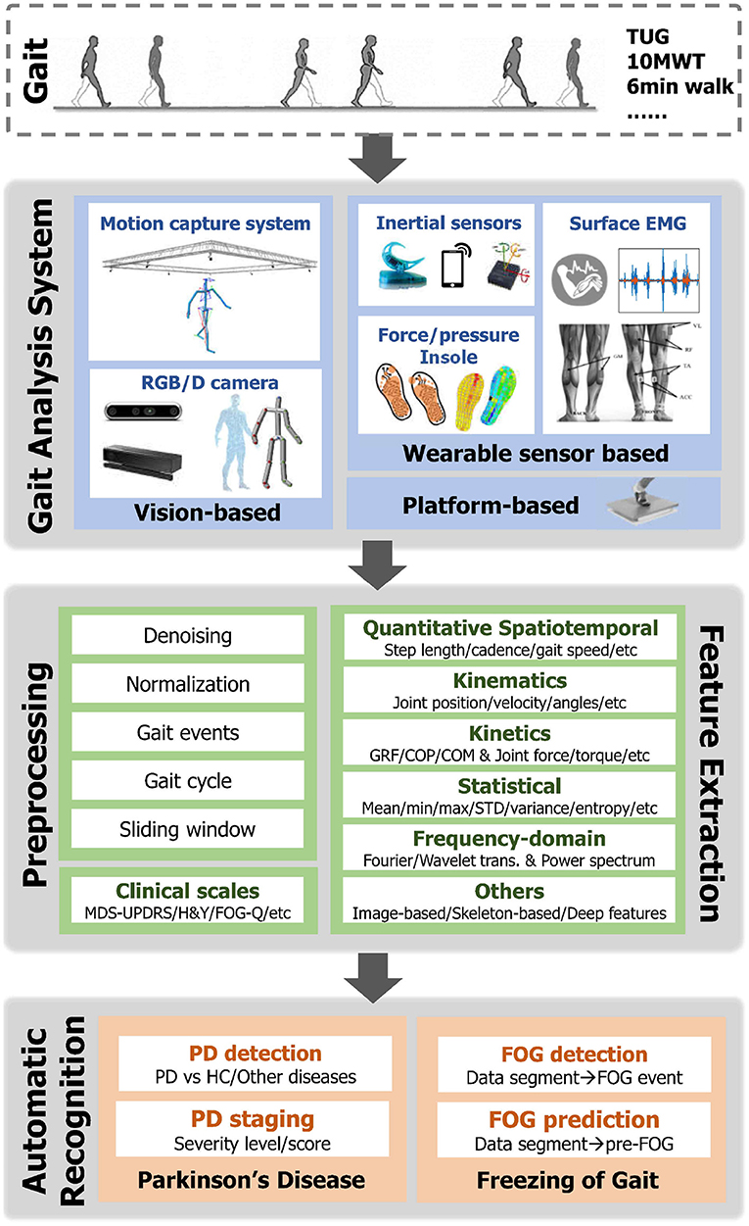


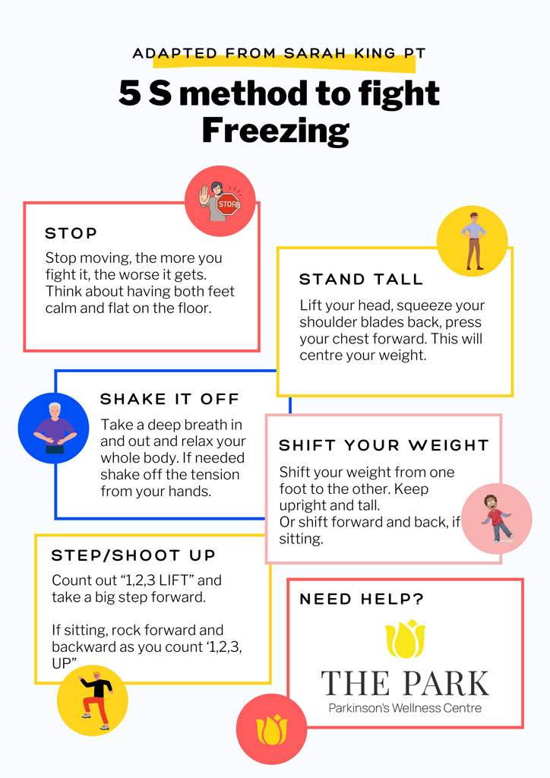
Clinical context (Movement Disorders Clinic):
PD progression is heterogeneous. Some patients experience rapid gait deterioration and freezing of gait, while others remain stable for years.
Engineering challenge:
Design a longitudinal monitoring solution to identify early markers of functional decline and support personalized treatment planning.
Constraints
- Suitable for home or outpatient use
- Long-term adherence
- Clinically meaningful summaries (not raw data)
Expected focus
- Wearables (IMUs, pressure, EMG) or hybrid systems
- Progression biomarkers (variability, asymmetry, event frequency)
- Ethical considerations and patient burden

PBL Problem 9: Surgical Outcome Prediction in Functional Neurosurgery
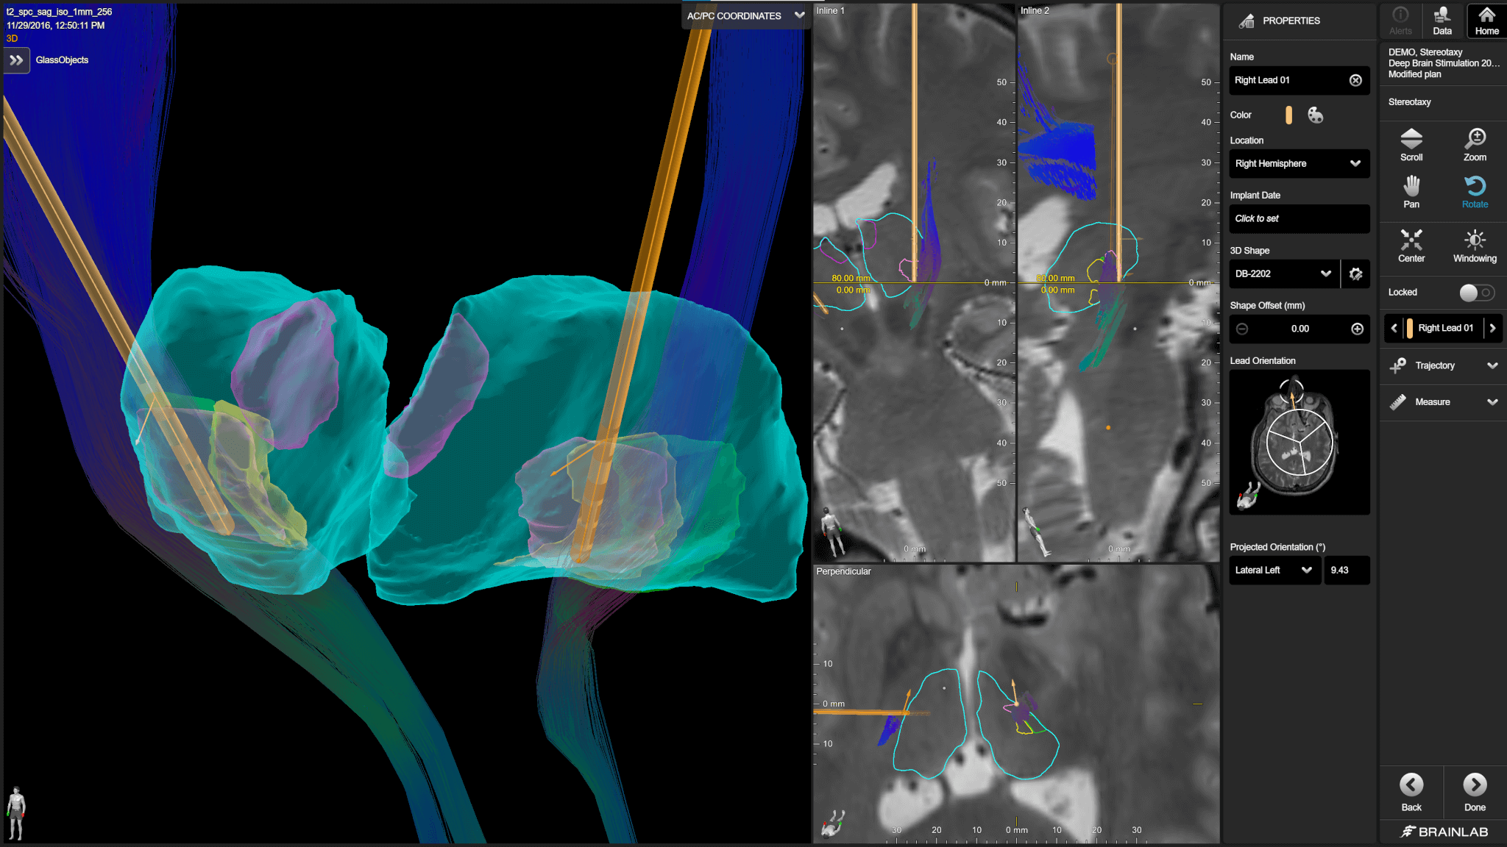
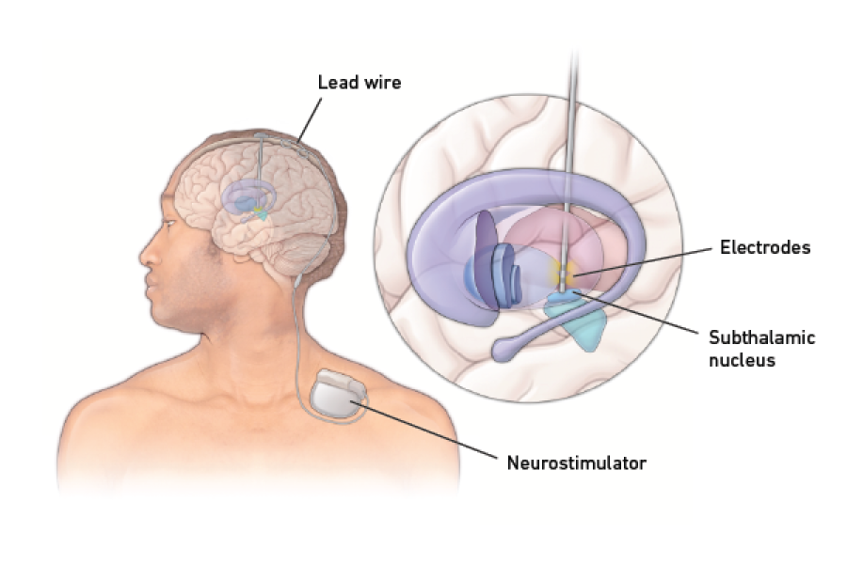
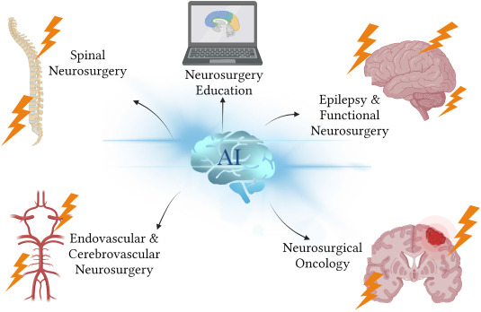
Clinical context (Neurosurgery & DBS Program):
Patients undergoing deep brain stimulation (DBS) or other functional neurosurgical procedures show variable outcomes, even with similar clinical profiles.
Engineering challenge:
Develop a pre-operative or peri-operative decision-support concept to predict functional outcomes or optimize targeting.
Constraints
- Must integrate with surgical planning workflows
- Interpretability is critical
- Small, heterogeneous datasets
Expected focus
- Data fusion (imaging, clinical scores, electrophysiology)
- Risk–benefit modeling
- Communication of uncertainty to surgeons and patients

PBL Problem 10: Quantifying Fatigue and Relapse Risk in Multiple Sclerosis
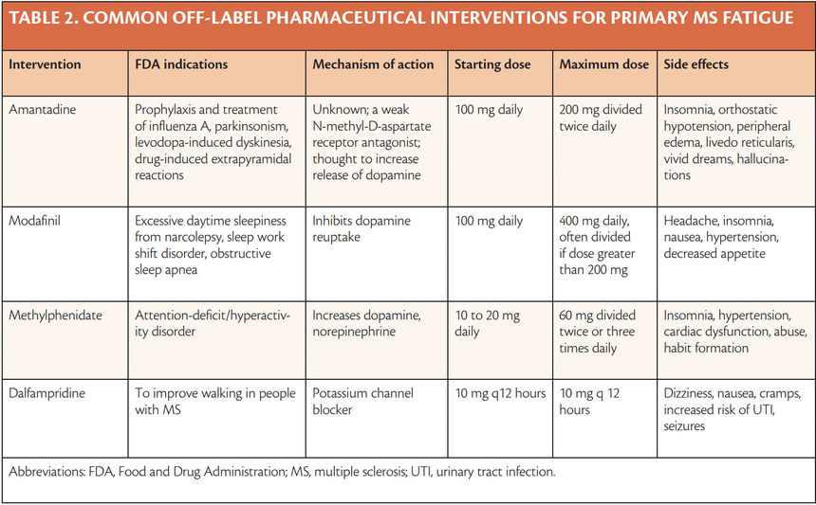
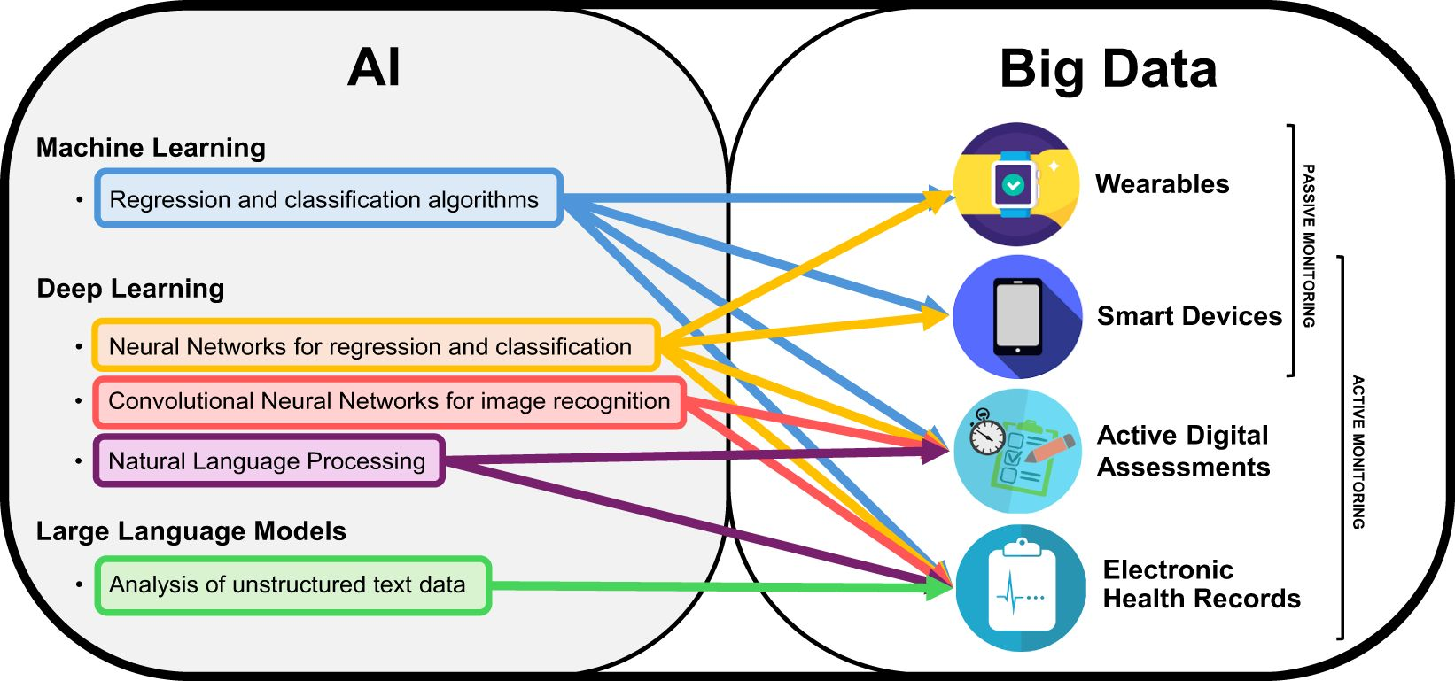
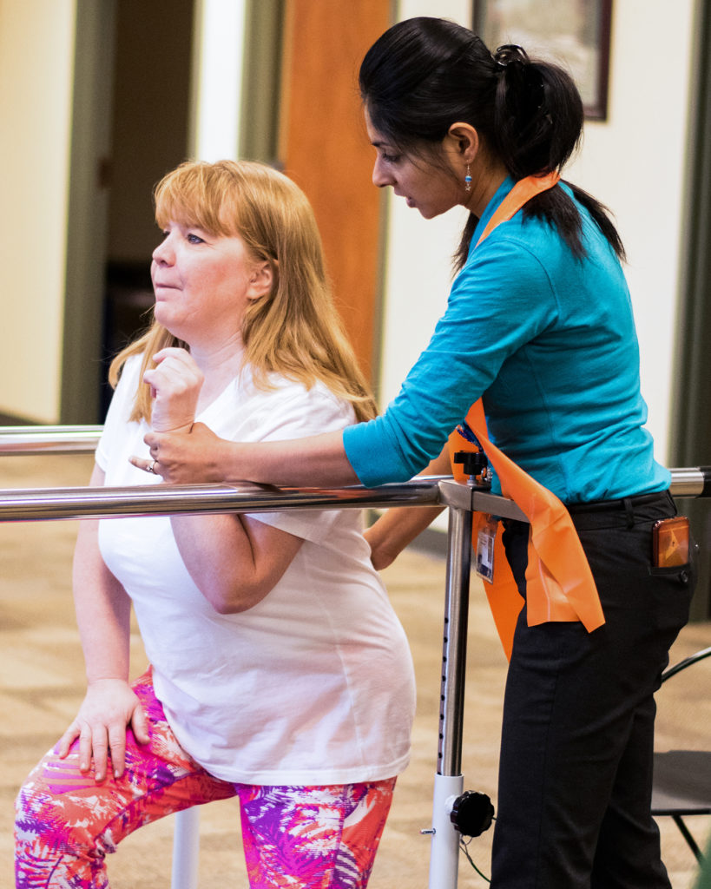
Clinical context (MS Program & Rehabilitation):
Fatigue is one of the most disabling MS symptoms, yet it is largely self-reported and poorly captured by routine clinical metrics.
Engineering challenge:
Design an objective assessment framework to quantify fatigue, mobility decline, or relapse risk during daily life or rehabilitation.
Constraints
- Sensitive to day-to-day variability
- Non-burdensome for patients
- Actionable for neurologists and therapists
Expected focus
- Multimodal sensing (activity, physiology, cognition)
- Fatigue indices and trend analysis
- Clinical interpretation and limitations

PBL Problem 11: Rehabilitation Technology That Transfers to the Real World
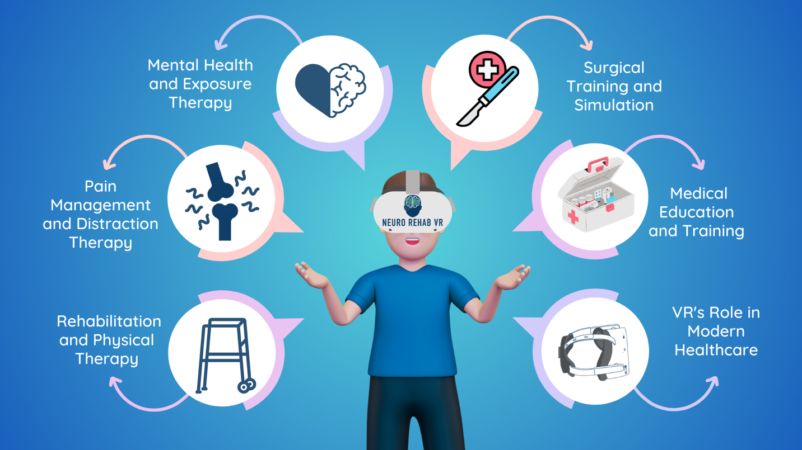
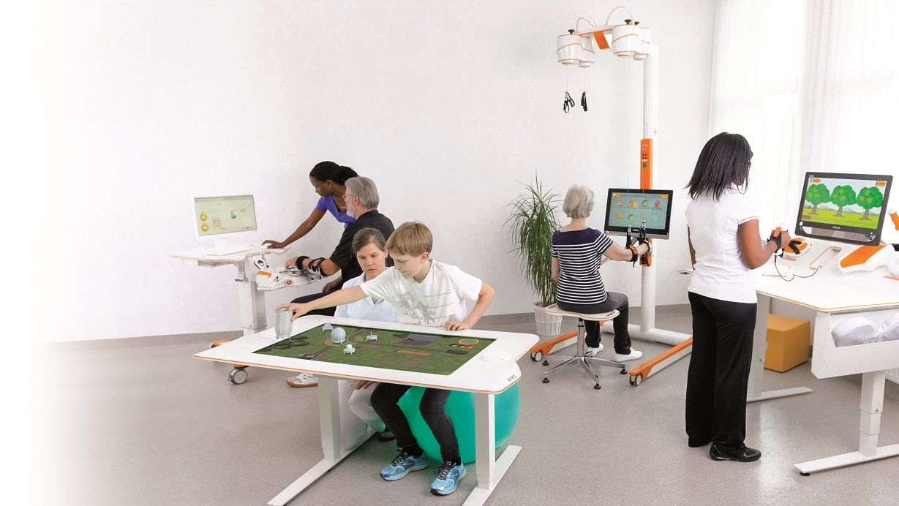

Clinical context (Neuro-Rehab Program):
Patients often perform well in structured therapy environments but fail to transfer gains to real-world tasks requiring attention, decision-making, and adaptability.
Engineering challenge:
Propose a rehabilitation technology or assessment system that targets cognitive-motor integration and predicts real-world functional carryover.
Constraints
- Safe for neurological populations
- Scalable within a hospital rehab program
- Objective outcome metrics
Expected focus
- Task design (dual-task, VR, adaptive feedback)
- Physiological + behavioral metrics
- Translation to discharge planning

